Digital Image Processing

CE-38-b

MISHAAL SAFEER

SAMEEN ABBAS

FOHA KHALID

Muhammad HASHIR SHOAIB

2019

# Task:

For the image given below (provided with the lab handout), apply the connectected component labelling and count the total number of white objects. First threshold the images ( replace pixel values less than 127 equal to 0 and above 127 equal to 1) and then do connected component analysis.

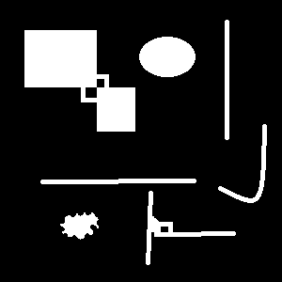

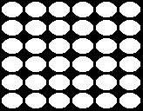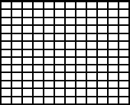

## Algorithm:

# newarray = np.array([  
# [1, 1, 1, 1, 1, 1, 1, 1, 1, 1],  
# [1, 255, 255, 255, 1, 1, 1, 1, 1, 1],  
# [1, 255, 255, 255, 1, 1, 1, 1, 1, 1],  
# [1, 255, 255, 255, 1, 1, 1, 1, 1, 1],  
# [1, 1, 1, 1, 1, 1, 1, 1, 1, 1],  
# [1, 1, 1, 1, 255, 1, 1, 255, 255, 1],  
# [1, 1, 1, 1, 255, 1, 1, 255, 255, 1],  
# [1, 1, 1, 1, 255, 255, 255, 255, 255, 1],  
# [1, 255, 255, 255, 255, 255, 255, 255, 255, 1],  
# [1, 255, 255, 255, 255, 255, 255, 255, 255, 1],  
# [1, 1, 1, 1, 1, 1, 1, 1, 1, 1]])

# row, col = np.shape(newarray)  
  
labels = [] # [,200, 180, 180, 120, 80, 40]  
for i in range(2, 555):  
 labels.append(i)  
print(labels)  
equilencyList = []  
# Raster scan step 1  
for i in range(0, row):  
 for j in range(0, col):  
 if newarray[i][j] != 1:  
 if newarray[i-1][j] == 1 and newarray[i][j-1] == 1: # check top and left, if both background then true  
 temp = labels.pop()  
 equilencyList.append([temp, temp])  
 newarray[i][j] = temp # give new label  
 elif newarray[i-1][j] == newarray[i][j-1]: # if top and left are equal, then copy same value  
 newarray[i][j] = newarray[i-1][j]  
 elif newarray[i-1][j] == 1: # if top is background then copy value of left  
 newarray[i][j] = newarray[i][j-1]  
 elif newarray[i][j-1] == 1: # if left is background then copy value of top  
 newarray[i][j] = newarray[i-1][j]  
 else: # if different objects but connected  
 if newarray[i-1][j] < newarray[i][j-1]:  
 newarray[i][j] = newarray[i-1][j]  
 for x in equilencyList:  
 if x[1] == newarray[i][j-1]:  
 x[1] = newarray[i - 1][j]  
  
 else:  
 newarray[i][j] = newarray[i][j-1]  
 for x in equilencyList:  
 if x[1] == newarray[i - 1][j]:  
 x[1] = newarray[i][j-1]

# Raster scan step 2  
for i in range(0, row):  
 for j in range(0, col):  
 if newarray[i][j] != 1:  
 for x in equilencyList:  
 if newarray[i][j] == x[0]:  
 newarray[i][j] = x[1]  
  
# count number of object in picture  
countList = []  
for x in equilencyList: # [:][1:1]  
 countList.append(x[1])  
count = len(np.unique(countList))  
  
# Printing  
print(**"Number of objects"**, count)  
print(**"Equivalency list"**, equilencyList)  
print(**"Image"**, newarray)  
cv.imwrite(**"newarray.png"**, newarray)

## Result:

Number of objects: 36

Equivalency list [[554, 514.0], … , [259, 259], [258, 258]]

Image [[1. 1. 1. ... 1. 1. 1.]

[1. 1. 1. ... 1. 1. 1.]

[1. 1. 1. ... 1. 1. 1.]

...

[1. 1. 1. ... 1. 1. 1.]

[1. 1. 1. ... 1. 1. 1.]

[1. 1. 1. ... 1. 1. 1.]]

